Lesson 21 Trajectory Tracking with Choreo

The next skill to learn is how to have your robot follow a path. This can be done with the techniques that you already know. You can drive/turn/drive and get the robot to where it needs to be. This however is very slow and will not be competitive. Over the years, the wpilib library has evolved to the most sophisticated app called Choreo (the constraint-honoring trajectory planner and editor). Choreo is optimised for swerve drive robots like our 2026 competition unit. In this lesson you will program autonomous path-following for a Romi differential drive robot. Because Romi uses a differential (tank) drive configuration [12.11], you can test time-optimal paths right on your desktop using simulation [12.11] before running them on the physical hardware. [1, 2, 3, 4, 5, 6]

To begin, open your Romi 2026 branch in VSCode and update your branch from the main branch. If it is not installed, install the vendor dependency Choreo.
https://choreo.autos/lib/ChoreoLib2026.json

Press control/shift/p and select: Wpilib:Manage Vendor Libraries and then: Install new Libraries (online). ChoreoLib should come up if it is not already installed. You want ChoreoLib 2026.03

One more item to get set up is to create a new folder to store your paths. In your branch go to src/main/deploy. Right Click on deploy and then Add New Folder and name it choreo.
Getting Started with Choreo and WPILib
- The detailed introduction to choreo is found at: https://choreo.autos/
- Open this site and read through the description. When you get to Installation, click on Releases. For this session, we are going to stay with version 2026.03. Select from Assets the version that corresponds to your computer. For the lab computers we use: Choreo-v2026.0.3-Windows-x86_64-setup.exe (If you don’t see it, select show all assets at the bottom.)
- Download and open the desktop application.
- Now you are ready to start setting up your first autonomous path. To learn how choreo works, read: https://choreo.autos/usage/editing-paths/.
- Now we will set up a new project configured for a differential drivebase. Some parameters have to be entered into the swerve configuration and then we switch to the differential drive.
- Input your Romi's physical constraints (track width, max velocity, and max acceleration) into the profile settings. [1, 2, 3]
- Go to the Robot Configuration panel and enter the parameters from these two screen shots, The first is set to Swerve and the second is Differential.

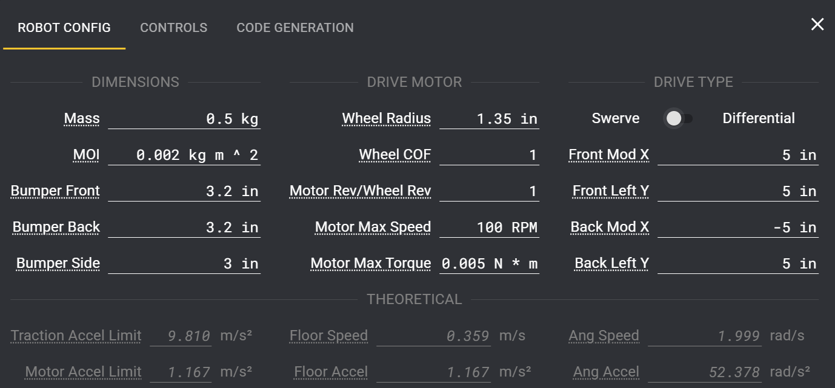
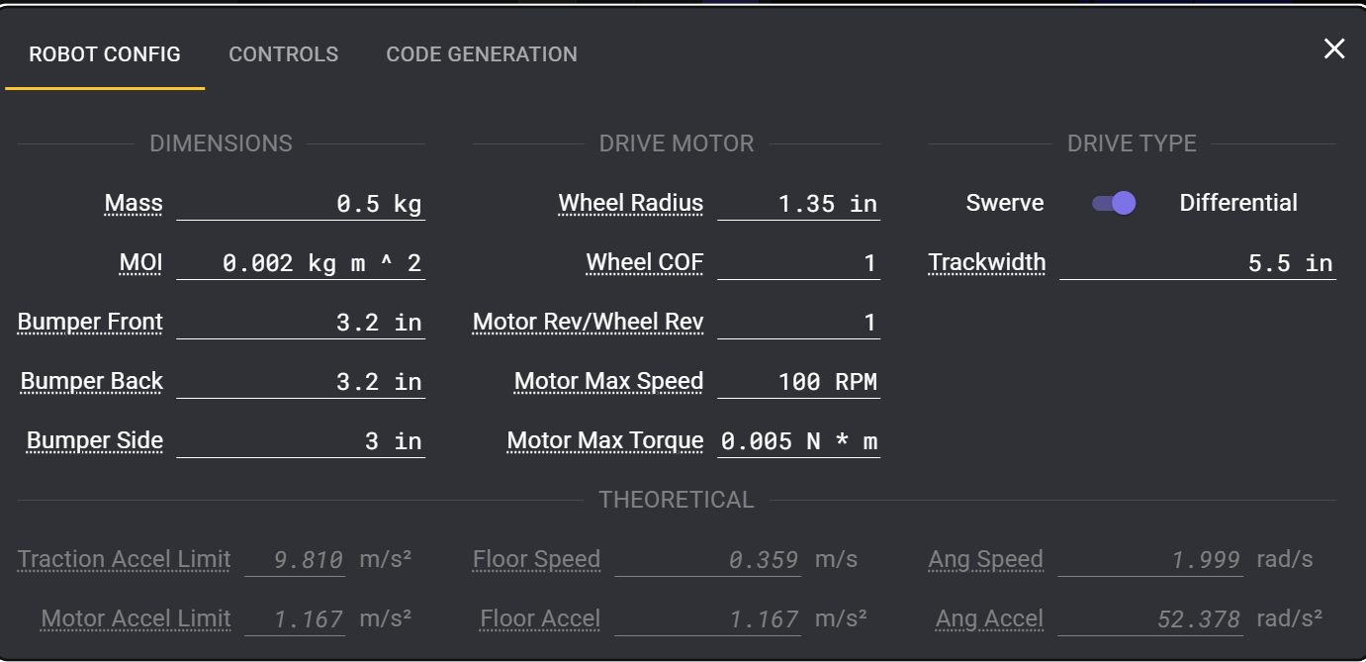
- While still on this screen, select CODE GENERATION.

Set config to put results into choreo folder.
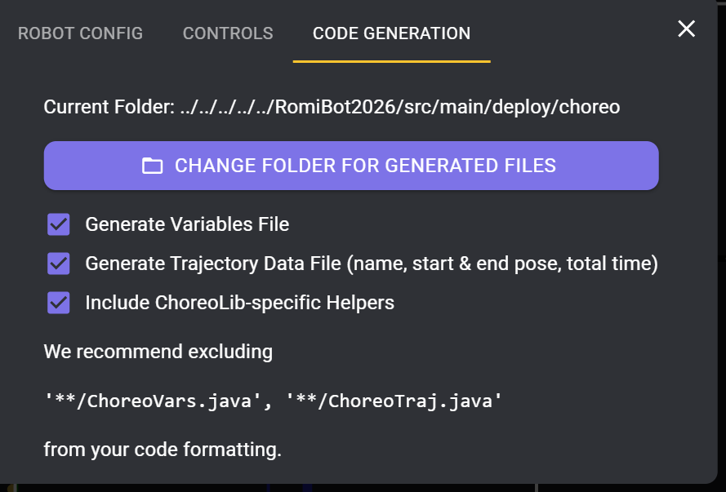

Exporting and Project Setup
- Draw your desired autonomous path using waypoints and constraints inside the Choreo UI.
- Name your first path Path1.
- Ensure your Romi project is set up using the standard WPILib VS Code extension. [1, 2, 3, 4, 5]
Simulating and Running on Romi
- Build your robot code containing the path-following logic using ChoreoLib or WPILib trajectory utilities.
- Power on your Romi and connect your computer to its Wi-Fi network.
- Open the WPILib Command Palette (Ctrl + Shift + P) in VS Code and launch Simulate Robot Code (F5) to watch your desktop code drive the physical Romi through your Choreo-optimized path. [1, 2, 3, 4, 5] PUT ROBOT ON THE FLOOR BEFORE STARTING CODE!

